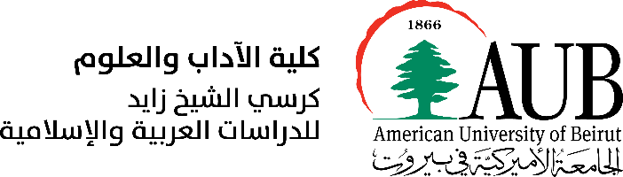 [logo](http://oriental-studies.org.ua/)

**ADDITIONAL CALL FOR PAPERS**

International Academic Conference

“Ahatanhel Krymskyi and Lebanon”

In light of the worldwide effects of COVID-19 and due to logistical reasons, the Organizing Committee that represents the Embassy of Ukraine in the Lebanese Republic, the Department of Arabic and Near Eastern Languages at the American University of Beirut (AUB), the Sheikh Zayed Chair for Arabic and Islamic Studies at AUB, and the A. Krymskyi Institute of Oriental Studies of the National Academy of Sciences of Ukraine, has decided to postpone the conference “Ahatanhel Krymskyi and Lebanon” which was initially set to take place on June 8-9, 2021 in an all-online format. The conference is postponed to November 11-12, 2021, and will be held as a hybrid event (both in-person and online), but depending on the circumstances we hope to welcome as many participants as possible at the American University of Beirut.

This conference aims to bring to light Ahatanhel Krymskyi’s works as a part of Lebanese history within the context of the Ottoman Empire and the Arab Nahda, and as a common page in Ukrainian-Lebanese relations. Therefore, we are particularly interested in papers that explore the following topics:

* Ahatanhel Krymskyi as a founder of the East-European academic school of Middle East Studies
* Krymskyi in Lebanon (1896–1898): sites, trips, social environment.
* “Beirut Stories” and “Palm tree branches” by A. Krymskyi
* Krymskyi as a researcher of Lebanese history, everyday life, and colloquial Arabic at the end of the XIX century
* Krymskyi’s contribution to the Middle East studies: Classical and Modern Arabic Literature, Islam and Sufism, History of Arabic Language, etc
* Krymskyi’s as a translator of the Arabic and Persian classical literature

Papers related to Krymskyi’s contribution to other fields of Middle Eastern Studies will be accepted too.

Working languages: Arabic, English, French.

Hosts of the Conference are planning to publish a collection of abstracts (Book of Abstracts) of the participants before the event. Since the conference is postponed, the deadline for abstract was extended: abstracts, with up to 400 words, double-spaced, must be sent along with your full name, complete affiliation, and position, and your CV by October 15, 2021, to oip00@mail.aub.edu. Please note that this is a call for additional papers; authors who have already sent their abstracts, do not need to resubmit them unless they wish to submit an edited abstract or an entirely new one. Authors will be notified of abstract acceptance or non-acceptance individually by email.

Full papers of the participants will be included in the Book of Proceeding which will be published after the conference.

For inquiries, please contact Ms. Oksana Prokhorovych at oip00@mail.aub.edu.

Organizing Committee: Bilal Orfali, Maryna Hrymych, Oleksandr Bohomolov, Danylo Radivilov, Oksana Prokhorovych.